**Project Report Template**

1.Introduction:

* 1. **Overview**

An Event Management System provides campus event planners a flexible, fully integrated solution to simplify the event management process and keep your customers, faculty and students happy, while maintaining important reports and data for making real estate and future planning decisions.

* 1. **Purpose**

Event management is the process of creating and maintaining an event. This process spans from the very beginning of planning all the way to post-event strategizing. At the start, an event manager makes planning decisions, such as the time, location, and theme of their event.

2.Problem Definition & Design Thinking:

2.**1 Empathy Map**

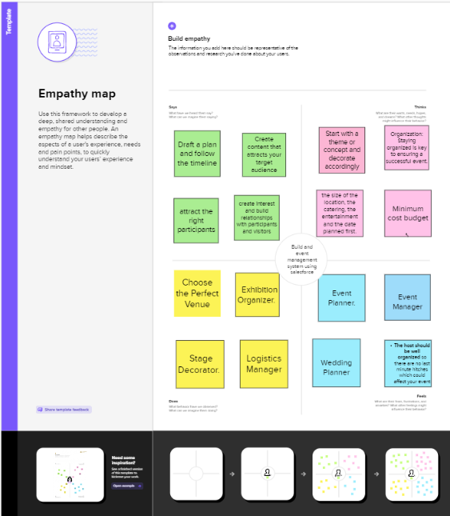

**2.2 Ideation & Brainstorming Map**

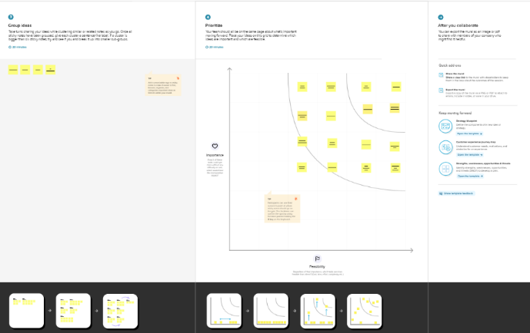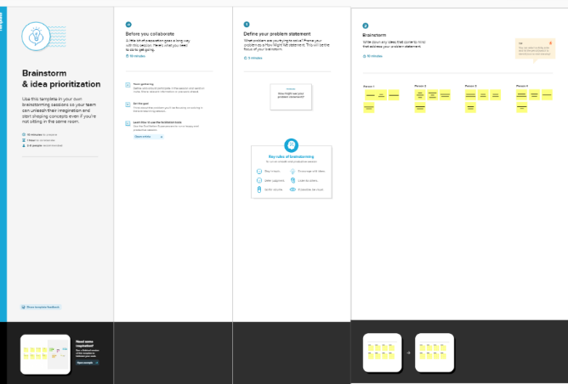

3.RESULT:

**3.1 Data Model*:***

|  |  |
| --- | --- |
| Object name | Fields in the Object |
| Event Management | |  |  | | --- | --- | | Field Label | Data Type | | Event | Text | | Events Name | Text | |
| Attendees | |  |  | | --- | --- | | Field Label | Data Type | | Attendee | Text | | Attendees Name | Text | |

**3.2 Activity & Screenshort**

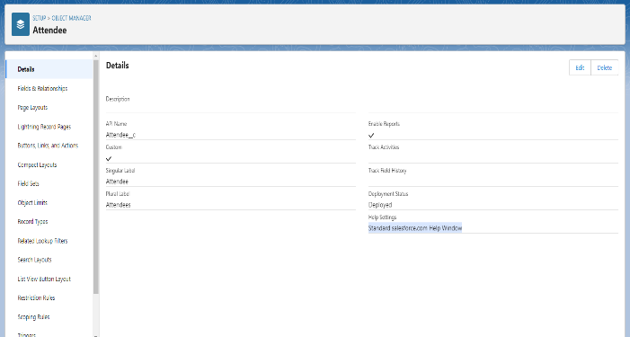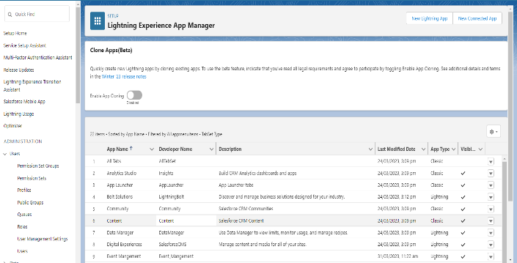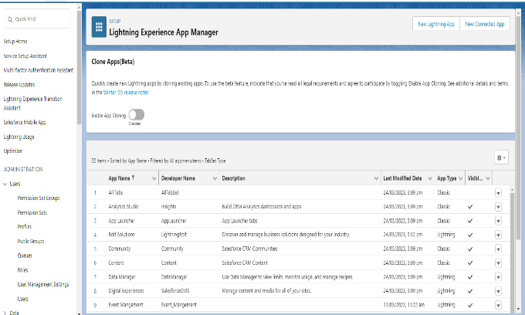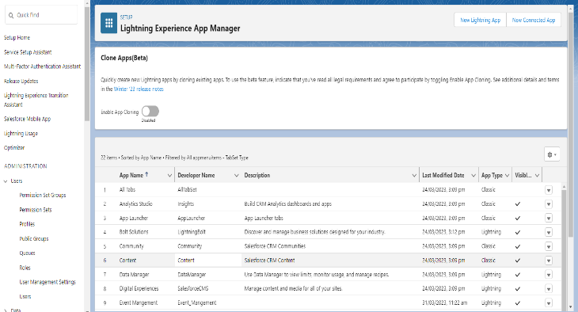

4 . Trailhead Profile URL:

Team Leader- <https://trailblazer.me/id/nvaitheeshwaran>

Team Member- https://trailblazer.me/id/nkamaleshwaran

Team Member- https://trailblazer.me/id/naravindh1

Team Member-https://trailblazer.me/id/nvivin

5. ADVANTAGES:

* It’s this experience and day to day exposure to the world of events that will bring creativity and a different perspective.
* Improve customer service and satisfaction.
* Improving incident detection and response time.
* Greater visibility into IT service delivery quality.

DISADVANTAGES:

* Keeping Track of Event Planning Process.
* Lack of Backup Plan for Bad Weather.
* Lack of Event Planning Experience.
* Time Management.

**6.**  APPLICATIONS:

* Even for the most organized person in the world, managing events is challenging
* Clients kept coming to us with event management woes so we decided to do something about them.
* We built a custom event management tool on Salesforce.
* Your communications serve as the foundation of your entire event.

**7.**  CONCLUSION:

* Conclude with recommendations for future events
* An event budget helps the event planners work within set parameters
* An event report can have many forms, but the purpose is the same, to prove event success.
* The reaction time a distribution system can be evaluated with an analytical method.

8. FUTURE SCOPE:

* Hosting events can redesign the structure of a city by facilitating economic growth, employment opportunities.
* Urban development, and promoting indigenous culture and heritage.
* It involves management, creation and development of events such as corporate conferences, wedding, festivities, formal parties.
* It involves a lot of research about the brand, target audience and the concept of the event before planning the actual event.